Role Description
Role Title: | Chief Financial Officer | Department: | Finance
Reports To: | Chief Executive | Last Updated: | May 2022

Role Purpose:
Cambridge Enterprise is the commercialisation arm of the University of Cambridge. Our mission is to help University of Cambridge innovators, experts and entrepreneurs make their ideas and concepts more commercially successful.

To achieve this we operate a multi-faceted business that includes managing the intellectual property portfolio for the university (which spends ~ £600m on research annually), licensing technology to industry, investing in new company formation from our seed fund investment unit and managing third party consultancy arrangements on the behalf of the University faculty.

Reporting to the Chief Executive Officer, the Chief Financial Officer (CFO) will be the finance lead for a dynamic finance function, serving an exciting and impactful organisation. The CFO will also be required to work with the CEO on the development and implementation of ambitious strategies for revenue growth and increased impact.

This role is responsible for the entire Finance Team of eight employees (FTE 6.7). The role requires a dynamic can-do mindset and has the requirement to draw upon a diverse set of skills and experience to ensure that the finance function fulfils its traditional operating purpose, serving a wide variety of stakeholders from academics, university departments, case managers, funders, licensees, clients and the senior leadership team, amongst others.

The role is also required to provide in-depth strategic support to the Chief Executive and the individual business units, taking responsibility for developing the financial strategy and business / investment cases to ensure the organisation effectively fulfils its remit as a global leading organisation in technology transfer.

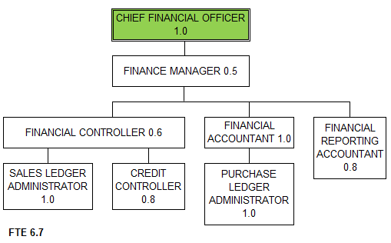

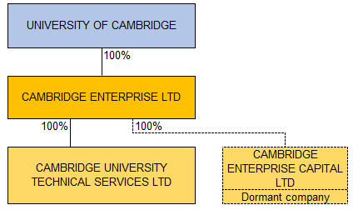

Main Responsibilities.
Strategy:
- Provide financial strategy recommendations to the Chief Executive and Senior Leadership Team (SLT). Develop the group financial strategy which articulates with and supports the overall Cambridge Enterprise strategy;
- Implement strategies and systems to improve financial performance. These include
  - Financial modelling of a revised patenting strategy for Cambridge Enterprise
  - Developing a business case and a methodology for tracking a new translational investment fund
  - Financial modelling and strategic financial advice for the seed funds investment unit which manages a £40m ever green venture fund for the university and has > £100m assets under management
  - Develop a multi-annual budgeting and financial modelling plan
  - Developing and managing a multi-annual investment plan for the university in Cambridge Enterprise
  - Benchmarking of investment and performance across peer institutions
- Assist with the development of the overall Cambridge Enterprise strategy and ensure financial articulation across the Group strategy (i.e. both Business Units and Support Functions);
- Identify and address potential financial risks for the Group.
- Manage the finance function for the business with overall responsibility for the finance team

Board and Senior Leadership Team (SLT):
- Board attendance & presentation of quarterly financials and analysis;
- Proxy Company Secretary for both Group Companies (for and on behalf of the Registrary);
- Manage the development and presentation of the annual budget to the SLT & Boards;
- Produce full quarterly board financial reports ensuring a full understanding by the board of the Group financial performance, position and financial risks;
- Active participation and membership of the SLT that has responsibility for overall strategic direction and operations of the company. Work actively with the Executive team on both operational and strategic issues related to Cambridge Enterprise;
- Support the Chief Executive with strategic projects, initiatives and managing the projects through University approval mechanisms.
- Manage the relationships between Cambridge Enterprise and the university financial teams

Team Leadership:
- Leadership of the Finance team, offering clear direction to the team, directing the development and implementation of an effective and progressive team strategy and operational plans, in line with the overall objectives of Cambridge Enterprise.
- Act as an advocate for the Finance Team and the Group;
- Encourage and cultivate an inspiring team environment that promotes Cambridge Enterprise values;
- Line management of the Finance Manager;
- Responsibility for the development of finance staff including ensuring the CPD capability of the team;
- Contributing to a culture of continuous service improvement across the finance team, to enable the delivery of a professional, efficient and forward-thinking quality finance service;
- Identifying and developing solutions for new finance and control processes and procedures.

Recurring and Ongoing Tasks & Responsibilities:
- Oversee all financial decisions or outcomes, such as budgeting and auditing;
- Oversee the process to value the Cambridge Enterprise portfolio of companies. Currently we hold equity positions in over 130 businesses.
- Manage business modelling across the Group and helping Business Units and Support Functions develop individual department business models for new and existing services and challenging when/where disconnects develop or where plans can be enhanced;
- Ensure that the control environment for the Group is fit for purpose, effective, operations un-encumbering as well as ensuring the company directors' can make their annual statutory statement with confidence;
- Review and approval of the annual tax packs, Group tax planning and annual tax compliance;
- Review of and approval of Finance Department invoices (initial and/or cascaded approvals);

Points of contact and Stakeholder Management:
- Point of contact for the University senior leadership in relation to Group financial queries & requests;
- Point of resource for the Group with regards to queries of finance, financial regulation, business taxation and finance related aspects such as insurance or financial regulations;
- Collaborate with the University Finance Division to maintain the financial efficacy for the Group (financial reporting, tax efficiency and insurance coverage);

Other:
- Maintain up-to-date knowledge of finance practices and accounting standards and other statutory requirements;
- Other tasks as appropriate to the role as may be reasonably requested.

Finance IT & systems:
- Sage 200 [accounting system];
- Sicon WAP [invoice approval];
- OneStream [University consolidation];
- ODBC [financial processes & reports].

Person Specification:
 | Required | Preferred
Experience | - Significant experience leading a finance team, at Head of Finance or CFO level.  - Experience in reporting to a Board and presenting complex financial information in a manner that enables informed decision making.  - Experience in developing strategic proposals and making decisions that drive a business forward.  - Experience in proactively developing business cases that tackle business challenges.  - Experience in managing a complex stakeholder environment – both internally and externally.  - Experience in managing the processes for financial forecasting and budgets, and overseeing the preparation of all financial reporting.  - Experience in establishing and developing relations with senior management and external partners and stakeholders.  - Well-developed people management skills with the ability to lead, motivate and inspire a team; | - Finance experience in a University or HEI environment.  - Experience in managing valuations of equity portfolios  - Experience in financial projection of revenues in a business with difficult to predict revenue streams (licenses and equity realisation)
Qualifications | - Qualified accountant (ACA, ACCA, CIMA or equivalent) or evidence of extensive experience at a CFO level.
Skills | - Excellent leadership skills.  - Strong problem solving skills – a capability to see opportunity in challenges.  - Knowledge of and competence in all finance and accounting processes and in running a finance and accounting function;  - Strongly self-motivated bringing gravitas, credibility, energy, resilience and commitment;  - Highly developed organisational skills, details-orientated with a meticulous attention to detail;  - Highly communicative and excellent interpersonal skills, with the ability to act as a representative of an organisation, and the ability to work positively with stakeholders to achieve effective outcomes;  - Solid experience of Microsoft Office, with in-depth knowledge of Excel.

